**ENCRYPTION ALGORITHM**

Algorithm DNAEncrypt (P,Key)

P is the plaintext which was read from textfile and Key is the Keyword

**Step 1:** Processing the Keyword. That is removing the duplicates from the Keyword and then map the characters into DNA ASCII Table.

**Step 2:** Arrange the above output into DNA Playfair Keymatrix.

**Step 3:** Convert the plaintext characters into DNA Bases.

**Step 4:** Apply playfair technique on these bases.

**Step 5:** After applying the resultant bases are Cipher text.

**DECRYPTION ALGORITHM**

**Step 1:** Read Encrypt data from the Text File and Key data.

**Step 2:** Split the data into 4 string.

**Step 3:** Mapped to the Key DNA Matrix and Apply “Play Fair”.

**Step 4:** Get Decrypted Data after applying play fair.

**Step 5:** Save the decrypted data as Text File.

**CODING**

1. **Generate Codan Matrix**

private void generate_dna_sequence_data_upto_255()

{

char[] data = { 'A', 'C', 'G', 'T' };

int index = 0;

for (int i = 0; i < 4; i++)

for (int j = 0; j < 4; j++)

for (int k = 0; k < 4; k++)

for (int m = 0; m < 4; m++)

{

String a = data[i].ToString() + data[j].ToString() + data[k].ToString() + data[m].ToString();

ascii_dna_code.Add(a);

index++;

}

for (int f = 0; f < ascii_dna_code.Count; f++)

codan.Add(Convert.ToChar(f).ToString(), ascii_dna_code[f].ToString());

int indexx = 0;

for (int i = 0; i < 16; i++)

{

for (int j = 0; j < 16; j++)

{

VAR_BASE_DNA_MATRIX[i, j]=codan[codan.Keys.ElementAt(indexx)];

indexx++;

}}}

1. **Generate Key Matrix**

public void generate_key_matrix(string UserEnteredkeyy)

{

key_remove_duplicate(UserEnteredkeyy);//"ArAj");

char[] key = keyList_without_duplicates.ToArray<char>();

List<string> DNA_match_Key_list = generate_char_array_to_matching_dna_sequence(key);

Generate_Key_Full_List(DNA_match_Key_list);

Display_matrix(KeyList_FUll);

}

private void Display_matrix(List<string> List_into_matrix)

{

int index = 0;

for (int i = 0; i < 16; i++)

{

for (int j = 0; j < 16; j++)

{

Console.Write(KEY_MATRIX[i, j] = List_into_matrix[index] + ",");

Console.Write("\t");

index++;

}

Console.WriteLine();

}

}

private void Generate_Key_Full_List(List<string> DNA_match_Key_list)

{

int count = 0;

for (int f = 0; f < ascii_dna_code.Count+DNA_match_Key_list.Count; f++)

{

if (f < DNA_match_Key_list.Count)

{

KeyList_FUll.Add(DNA_match_Key_list[f]);

}

else if (!KeyList_FUll.Contains(ascii_dna_code[count]))

{

KeyList_FUll.Add(ascii_dna_code[count]);

count++;

}

else

{

count++;

}}}//Generate Key Matrix

1. **Encryption Code**

private string getEncryptText(string splittext)

{

string encrypttext = null;

int index = 0;

string nextdata1 = null, nextdata2 = null,nextdata3 = null, nextdata4=null;List<string> get_codanto_encryptlist = new List<string>();

foreach (char c in splittext.ToCharArray())

{

string value;

codan.TryGetValue(c.ToString(), out value);

get_codanto_encryptlist.Add(value);

}

int[] row = new int[2]; int[] col = new int[2];

for (int i = 0; i < 16; i++)

{

for (int j = 0; j < 16; j++)

{

if (index < get_codanto_encryptlist.Count)

{

string compare_var = KEY_MATRIX[i, j];

if (compare_var.Equals(get_codanto_encryptlist[index]+","))

{

row[index] = i;

col[index] = j;

i = 0; j = 0;

index++;

}}}}

if (row[0] == row[1])

{

if (col[0] >= lastindex)

{

nextdata1 = KEY_MATRIX[row[0], col[0] - lastindex];

}

if (col[1] >= lastindex)

{

nextdata2 = KEY_MATRIX[row[1], col[1] - lastindex];

}

if (col[0] < lastindex)

{

nextdata1 = KEY_MATRIX[row[0], col[0] + 1];

//both are in same row

}

if (col[1] < lastindex)

{

nextdata2 = KEY_MATRIX[row[1], col[1] + 1]; }}

else if (col[0] == col[1]){

if (row[0] >= lastindex){

nextdata1 = KEY_MATRIX[row[0] - lastindex, col[0]];

}if (row[1] >= lastindex){

nextdata2 = KEY_MATRIX[row[1] - lastindex, col[1]];}

if (row[0] < lastindex)

{

nextdata1 = KEY_MATRIX[row[0] + 1, col[0]];

//both are in same row}

if (row[1] < lastindex){

nextdata2 = KEY_MATRIX[row[1] + 1, col[1]]; }

//both are in same Column}

else{

nextdata3 = KEY_MATRIX[row[0], col[1]];

nextdata4 = KEY_MATRIX[row[1], col[0]];

}

if (nextdata1 != null)

encrypttext += nextdata1;

if (nextdata2 != null)

encrypttext += nextdata2;

if(nextdata3!=null)

encrypttext += nextdata3;

if(nextdata4!=null)

encrypttext += nextdata4;

return encrypttext;

}////////Completed Encryption///////

1. **Decryption Code**

private void Decryption_with_Playfair(string encrypttext)

{

string[] dcryptext = new string[10];

List<string> userdata_split_into_2letters = Get_user_encrypt_text_data(encrypttext);

for (int i = 0; i < userdata_split_into_2letters.Count; i++)

{

string[] text = getDecryptText(userdata_split_into_2letters[i]).Split(',');

for (int j = 0; j < text.Length; j++)

{

if (text[j] != "")

{

var keys = from entry in codan where entry.Value == text[j] select entry.Key;

foreach (var key in keys)

DecryptList_Data.Add(key);

}}}}

public string getDecryptText(string encryptSplit)

{

string decrypttext = null;

int index = 0;

string decry_nextdata1 = null, decry_nextdata2 = null, decry_nextdata3 = null, decry_nextdata4 = null;

List<string> get_codanto_decrylist = new List<string>();

for (int i = 0; i < encryptSplit.Length; i += 4)

{

string g = encryptSplit[i].ToString() + encryptSplit[i+1].ToString() + encryptSplit[i+2].ToString() + encryptSplit[i+3].ToString();

get_codanto_decrylist.Add(g);//value);

}

int[] decry_row = new int[2]; int[] decry_col = new int[2];

for (int i = 0; i < 16; i++)

{for (int j = 0; j < 16; j++)

{

if (index < get_codanto_decrylist.Count)

{

string compare_var = KEY_MATRIX[i, j];

if (compare_var.Equals(get_codanto_decrylist[index] + ","))

{decry_row[index] = i;

decry_col[index] = j;

i = 0; j = 0;

index++;

}}}}

if (decry_row[0] == decry_row[1])

{

if (decry_col[0] > lastindex)

{

decry_nextdata1 = KEY_MATRIX[decry_row[0], decry_col[0] + lastindex];

}

if (decry_col[1] > lastindex)

{

decry_nextdata2 = KEY_MATRIX[decry_row[1], decry_col[1] + lastindex];

}

if (decry_col[0] <= lastindex)

{

if(decry_col[0]==0)

decry_nextdata1 = KEY_MATRIX[decry_row[0], decry_col[0] + lastindex];

else

decry_nextdata1 = KEY_MATRIX[decry_row[0], decry_col[0] - 1];

}

if (decry_col[1] <= lastindex)

{

if (decry_col[1]==0)

decry_nextdata2 = KEY_MATRIX[decry_row[1], decry_col[1] + lastindex];

else

decry_nextdata2 = KEY_MATRIX[decry_row[1], decry_col[1] - 1];

}

}

else if (decry_col[0] == decry_col[1])

{

if (decry_row[0] > lastindex)

{

decry_nextdata1 = KEY_MATRIX[decry_row[0] + lastindex, decry_col[0]];

}

if (decry_row[1] > lastindex)

{

decry_nextdata2 = KEY_MATRIX[decry_row[1] + lastindex, decry_col[1]];

}

if (decry_row[0] <= lastindex)

{

if (decry_row[0] == 0)

decry_nextdata1 = KEY_MATRIX[decry_row[0] + lastindex, decry_col[0]];

if (decry_row[0] == lastindex)

decry_nextdata1 = KEY_MATRIX[decry_row[0] - lastindex, decry_col[0]];

else if (decry_row[0] != 0)

{

decry_nextdata1 = KEY_MATRIX[decry_row[0] - 1, decry_col[0]];

}

//both are in same row

}

if (decry_row[1] <= lastindex)

{

if (decry_row[1] == 0)

decry_nextdata2 = KEY_MATRIX[decry_row[1] + lastindex, decry_col[1]];

if (decry_row[1] == lastindex)

decry_nextdata2 = KEY_MATRIX[decry_row[1] - lastindex, decry_col[1]];

else if (decry_row[1] != 0)

{

decry_nextdata2 = KEY_MATRIX[decry_row[1] - 1, decry_col[1]];

}

}

//both are in same Column

}

else

{

decry_nextdata3 = KEY_MATRIX[decry_row[0], decry_col[1]];

decry_nextdata4 = KEY_MATRIX[decry_row[1], decry_col[0]];

}

if (decry_nextdata1 != null)

decrypttext += decry_nextdata1;

if (decry_nextdata2 != null)

decrypttext += decry_nextdata2;

if(decry_nextdata3!=null)

decrypttext += decry_nextdata3;

if(decry_nextdata4!=null)

decrypttext += decry_nextdata4;

return decrypttext;

}///////Completed Decryption

**4.4 SCREENSHOTS**

1. **UI**

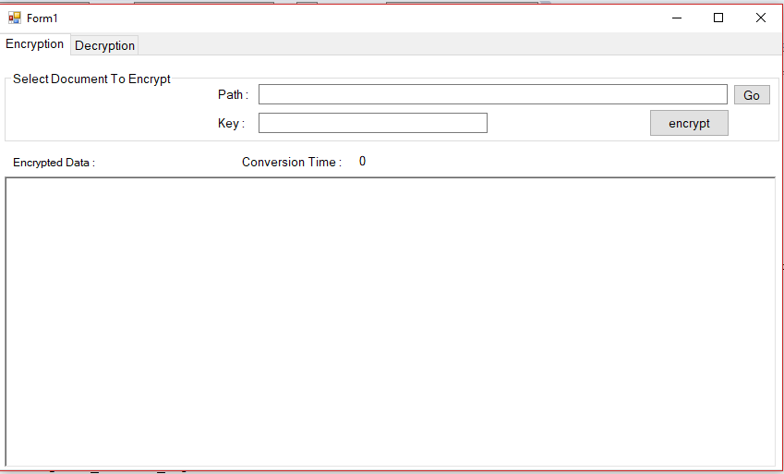

1. **Go Button Click**

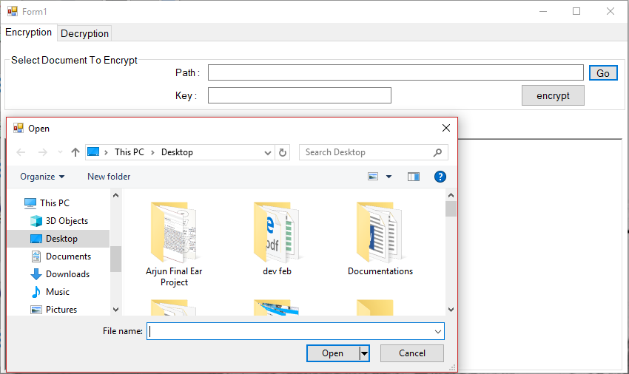

1. **Entering Encrypt Key**

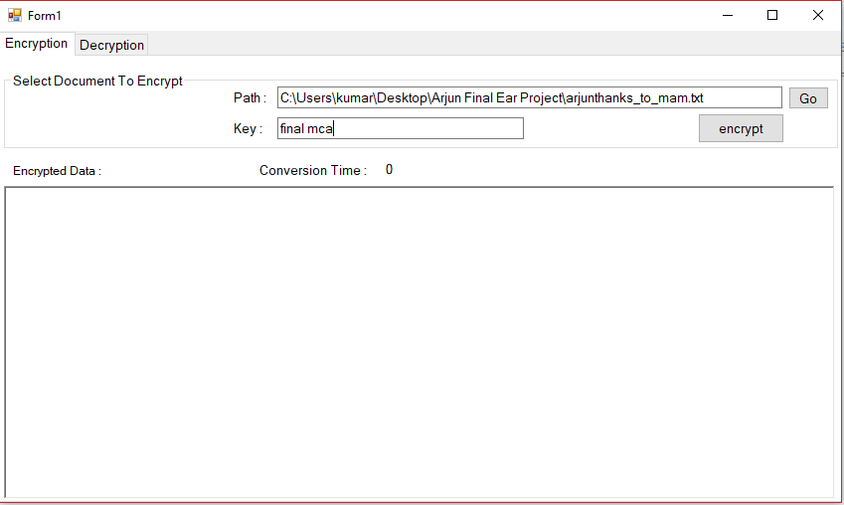

1. **Encryption Button Click**

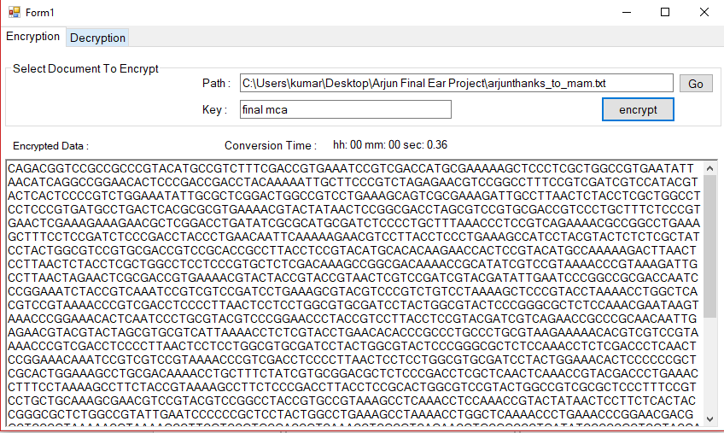

1. **Encrypt File Created**

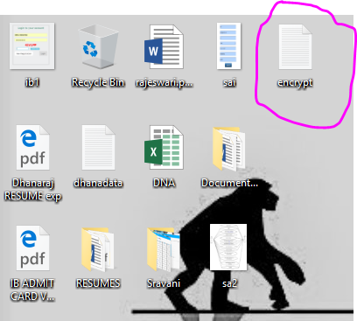

1. **Decryption => Go Button Click**

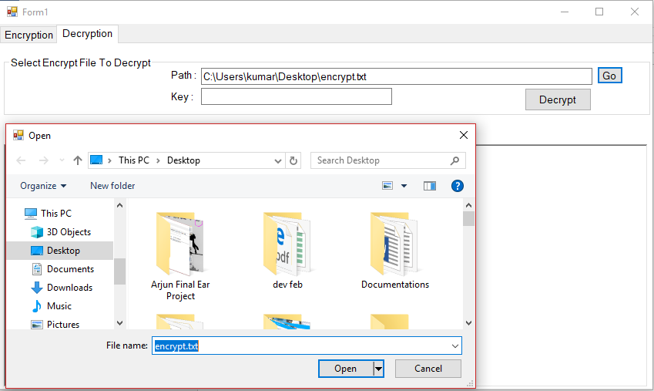

1. **Entering Decrypt Key**

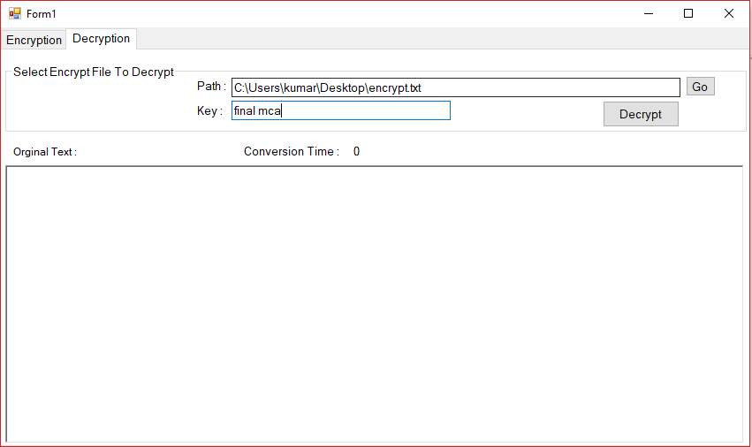

1. **Decryption Button Click**

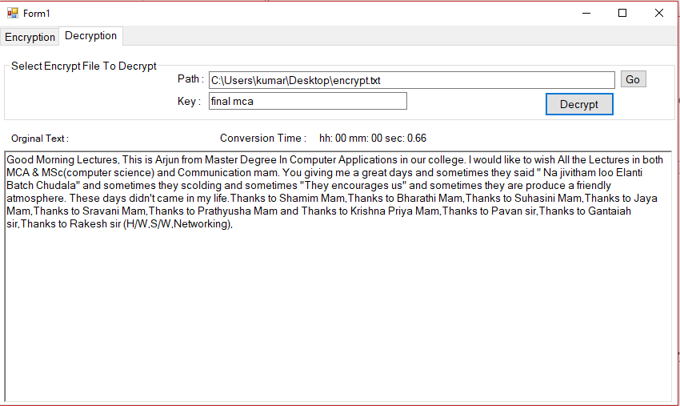

1. **Decrypt File Created**

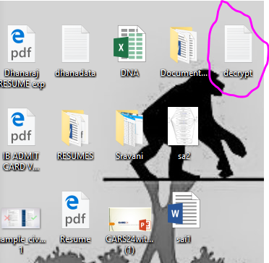

**RESULT ANALYSIS**

|  |  |  |
| --- | --- | --- |
| **SIZE** | **Encryption Time** | **Decryption Time** |
| **1 KB** | **0.011 sec** | **0.10 sec** |
| **5 KB** | **3.45 sec** | **7.32 sec** |
| **10 KB** | **5.23 sec** | **10.23 sec** |
| **50 KB** | **10.84 sec** | **26.54 sec** |